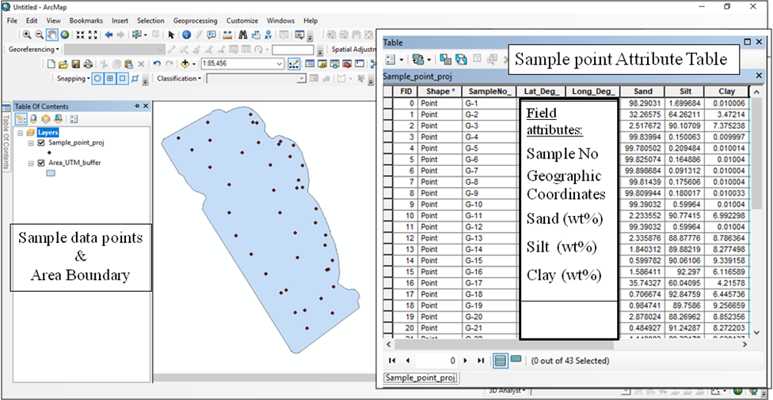
Loading of Sample data points with field attributes as follows
- Sample point no
- XY coordinates
- Sand (wt %)
- Silt (wt %)
- Clay (wt %)
Plate-1. Flow chart showing preparation of Sediment distribution map based on Folk (SSC) conditional string in Arc Gis 10.3

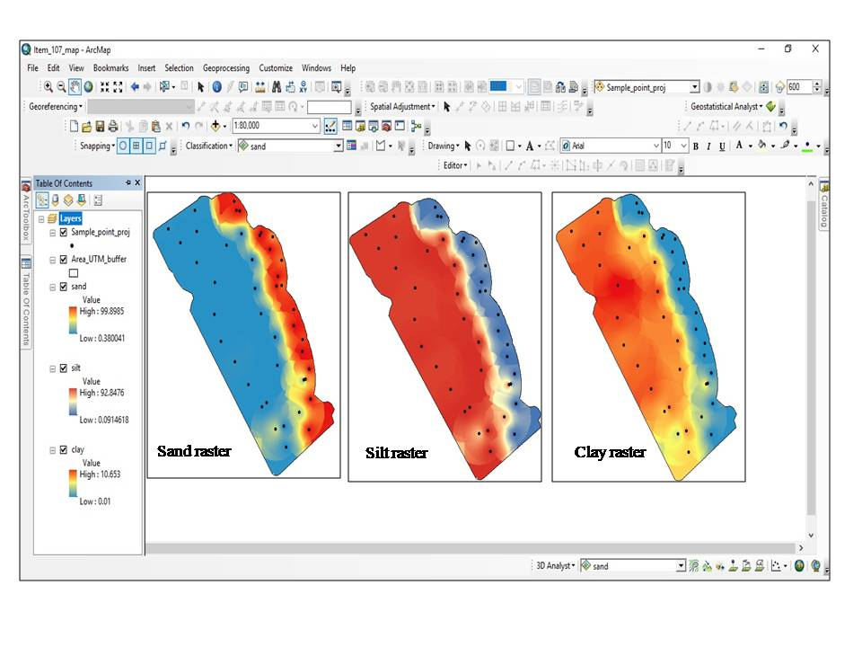
Creation of Sand, Silt & Clay rasters following IDW interpolation
Cont…..
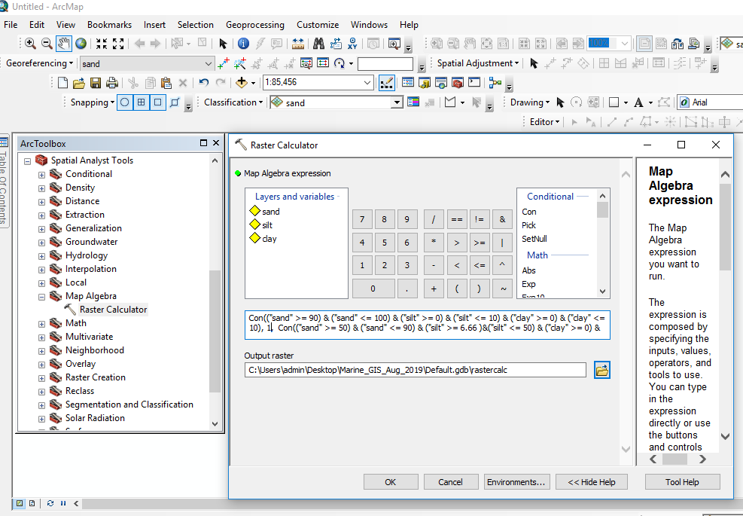
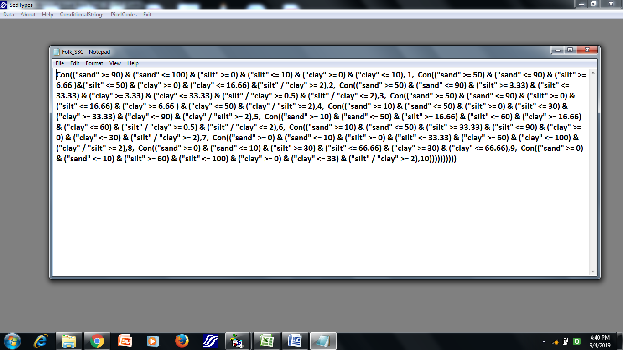
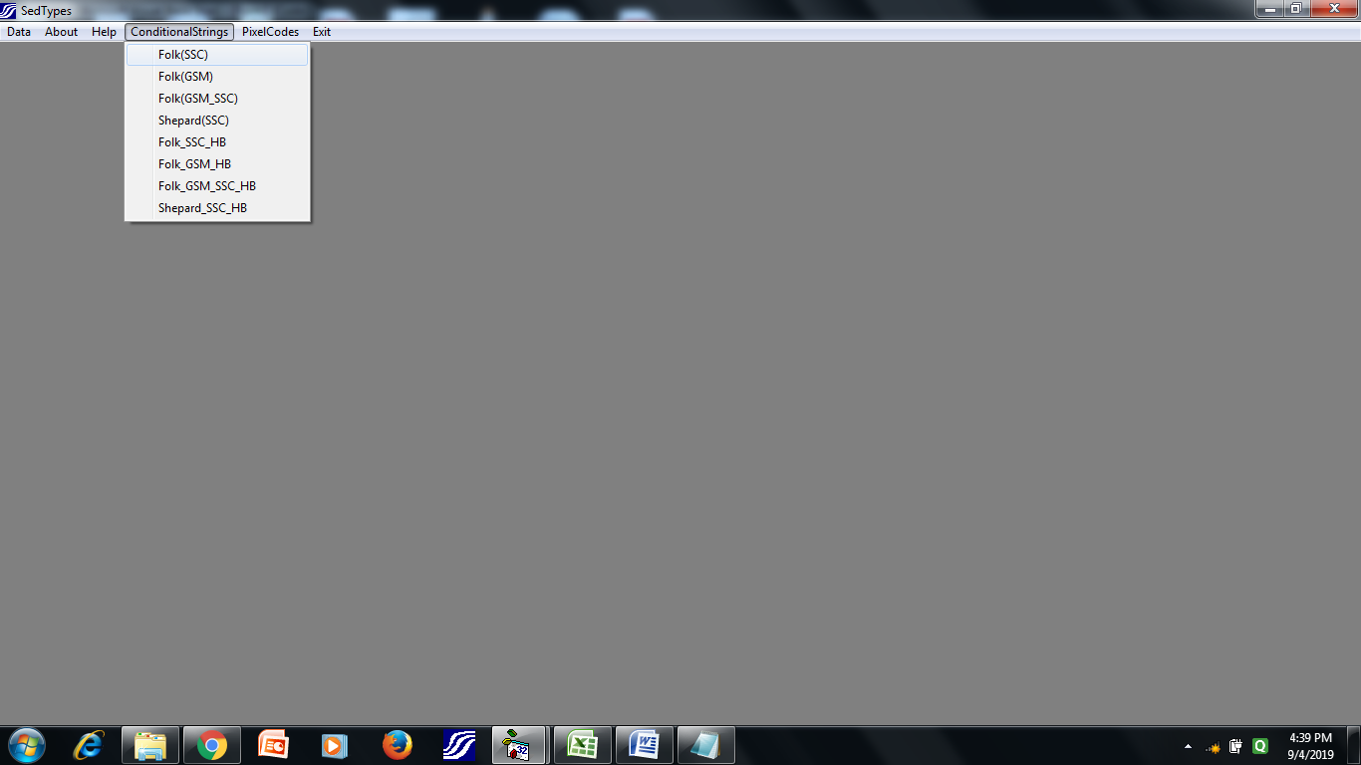
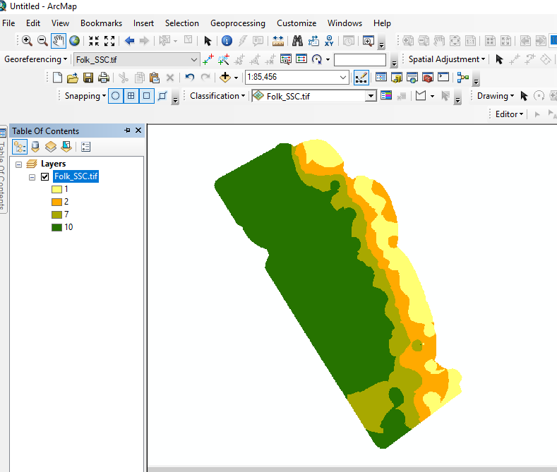
Open Folk (SSC) conditional string in Sed Types software and copy the same
Paste Conditional string in the raster calculator of map algebra
Final output raster

